REG NO: 22TD0058 NAME: NASRIN J YEAR/SEM/SEC: Y3/S6/B
MINI PROJECT
HOSPITAL MANAGEMENT SYSTEM
AIM:
To design and develop a windows form application for Hospital Management system using Vb.Net.
DESCRIPTION:
A Windows-based Hospital Management System developed using VB.NET is a comprehensive application that offers various functionalities essential for efficient hospital administration This application aims to streamline hospital operations, improve patient care, and enhance administrative efficiency by providing a user-friendly interface for meaning various aspects of a healthcare
REQUIREMENT ANALYSIS:
OPERATING SYSTEM : Windows 9, 10 and 11.
FRONT END : Microsoft Visual Basic 2022
BACK END : Ms-Access 2003/07
HARDWARE REQUIREMENTS:-
PROCESSOR : RAM INTEL PENTIUM 4 (OR) HIGHER
RAM : 512 MB & ABOVE
PRINTER : INK JET PRINTER
HARD DISK DRIVE : 500 MB FREE SPACE OR ABOVE
PROCEDURE:
Step 1: Select Microsoft Visual Basic 2022.
Step 2: Choose File New Project Windows Form Application.Save the project as Test.
Step 3: Creating new forms by choosing File New File Windows Form.
Step 4: Designing each and every form by placing the necessary labels, text box, buttons, drop down box, and grid views.
Step 5: Creating a new database connection as follows
Step 6: Choose Database Explorer and Right click on the Database connection then select Add new connection. Add connection window is appearing on the screen.
Step 7: Choose Data source as Microsoft SQL Server Database File (SqlClient), enter the database name and press ok. Then press the Test connection button to check the connection.
Step 8: In database to create tables such as registers, records and results.
Step 9: Establish a sql connection by using a namespace SqlClient.
Step 10: Build the application and run it.
DATA FLOW DIAGRAM (DFD):
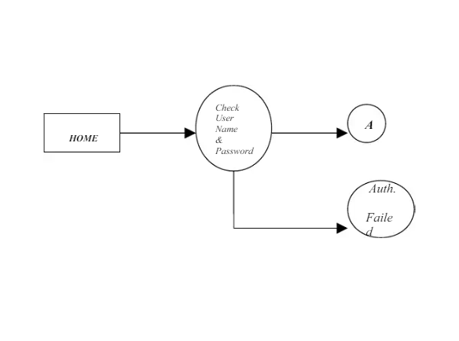
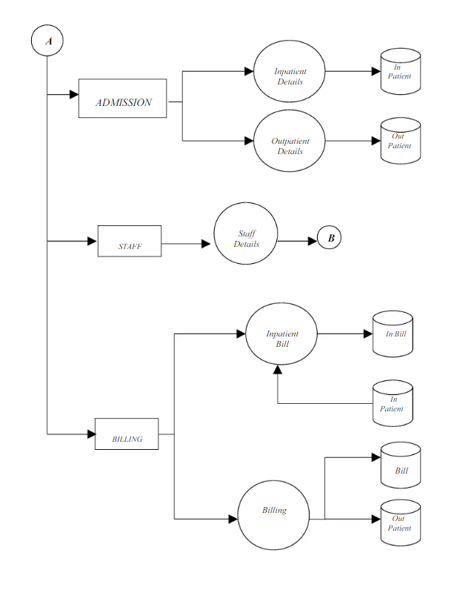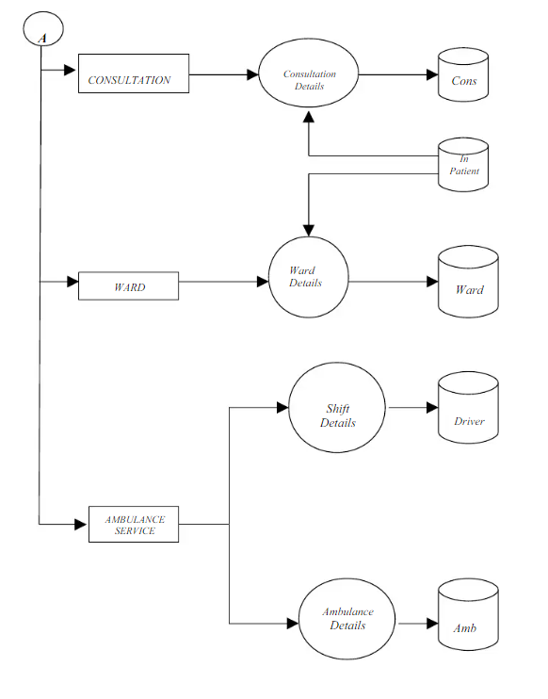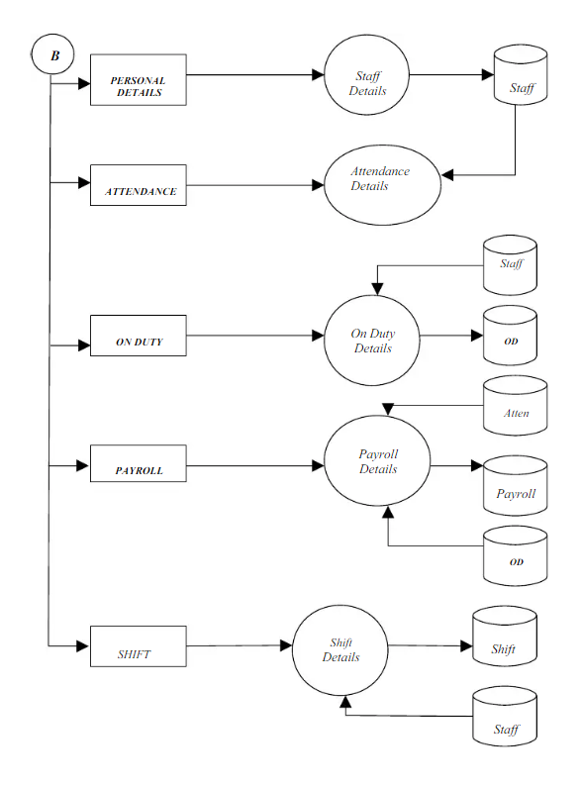

TABLE DESIGN:
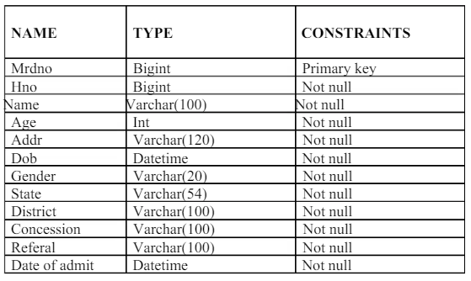
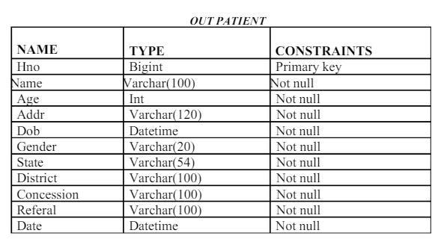

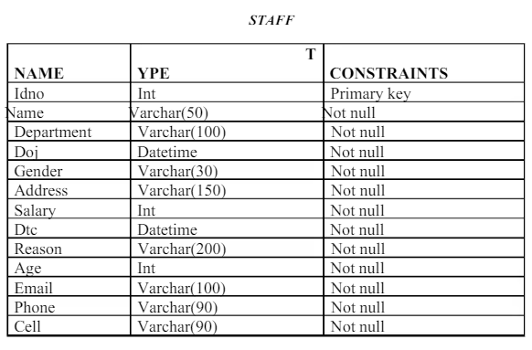
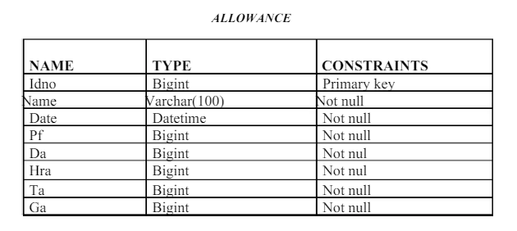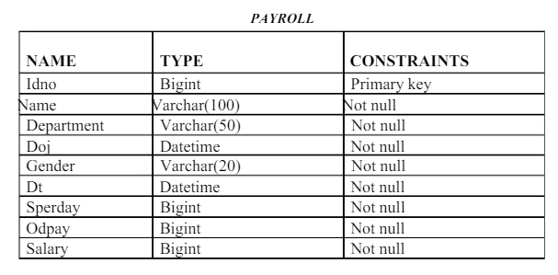

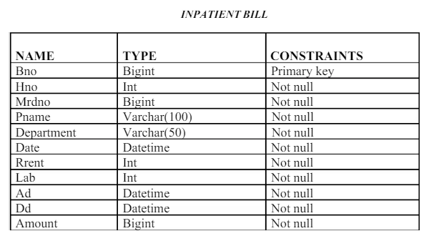
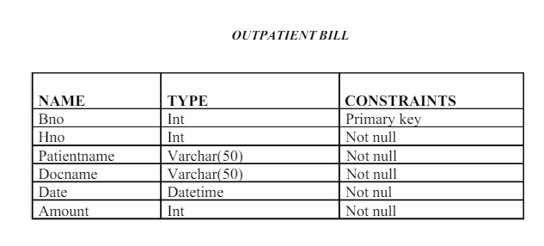
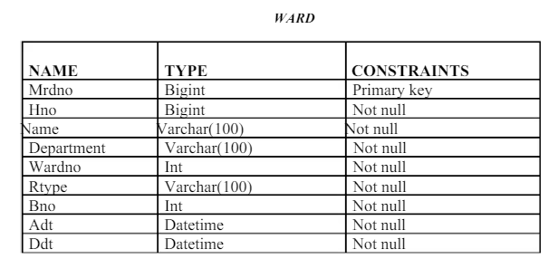
SAMPLE CODING:
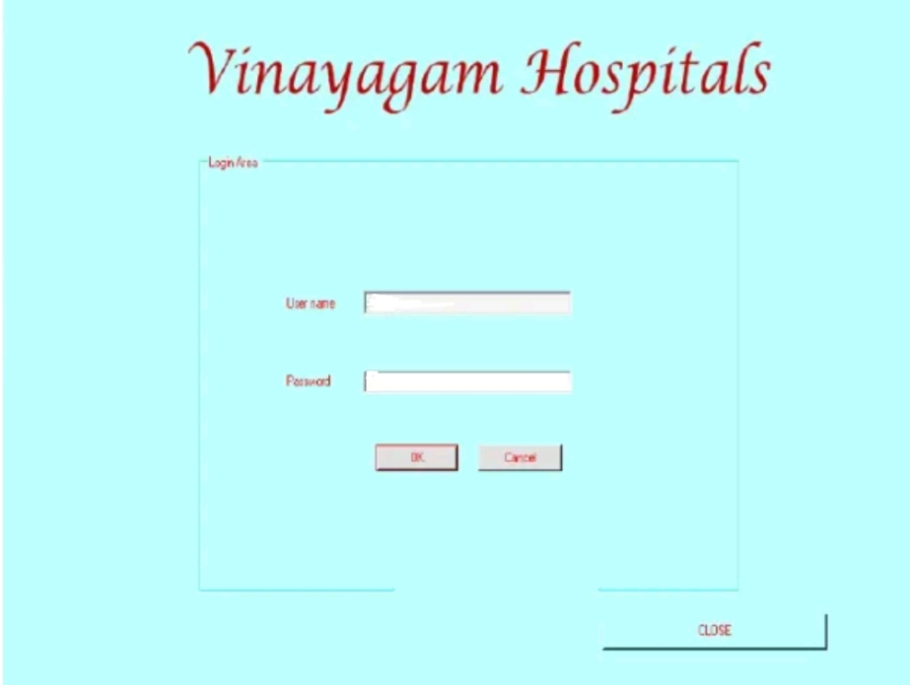
HOME SCREEN:

Public Class Login
Dim torml As New mainmenu
Private Sub OK_Click(ByVal sender As System.Object, ByVal e As System.EventArgs) Handles OR.Click
If PasswordTextBox.Text = "hospital" Then MsgBox("Login Success", MsgBoxStyle. Information, "Hospital Management")
PasswordTextBox.Text =
Me.llide()
Else mainmenu.Show()
MsgBox("Login Failed", MsgBoxStyle.Critical, "Hospital Management")
PasswordTextBox.Text =
End Sub
Me.Show()
End If
Private Sub Cancel Click (ByVal sender As System.Object, ByVal e As System.EventArgs) Handles Cancel.Click
Me.Close()
End Sub
Private Sub Button1_Click(ByVal sender As System.Object, ByVal e As System.EventArgs) Handles Buttonl.click
End
End Sub
End Class
MAIN MENU SCREEN:

Public Class mainmenu
Private Sub Exit ToolStripMenuItem_Click(ByVal sender As System.Object, ByVal e As System.EventArgs) End
End Sub
Frivate Sub InpatientToolStripMenuItem click (ByVal sender As System.Object, ByVal e As .System.EventArgs) Handles Inpatient ToolStripMenuItem.Click
Me. Hide ()
inpatient.Show()
End Sub
Private Sub Outpatient ToolStripMenuItem_Click(ByVal sender As System.Object, ByVal e As System.EventArgs) Handles Outpatient ToolStripMenuitem.click
Me.Hide ()
outpatient.Show()
End Sub
Private Sub DoctorToolStripMenuItem_Click(ByVal sender As System.Object, ByVal e As System.EventArgs)
Me.Hide()
doctper.Show()
End Sub
Private Sub DoctorToolStripMenuIteml Click(ByVal sender As System.Object, ByVal e As System.EventArgs)
Me.Hide()
docpay.show()
End Sub
Private Sub DoctorToolStripMenuItem2_Click(ByVal sender As System.Object, ByVal e As System.EventArgs)
Me.Hide()
doct.sal.Show(
End Sub
Private Sub Personal Details ToolStripMenuTtem_Click(ByVal sender As System.Object, ByVal e As System.EventArgs) Handles Personal Details ToolStripMenuItem.Click
Me.Hide()
doct.per.Show()
End Sub
Private Sub mainmenu_oad(ByVal sender As System.Object, ByVal e As System.EventArgs) Handles MyBase.Load
End Sub
Private Sub DoctorToolStripMenuItem3_Click(ByVal sender As System.Object, ByVal e As System.EventArgs)
Me.Hide()
End Sub
doctate.Show()
Private Sub DoctorToolStripMenuItem4_Click(ByVal sender As System.Object, ByVal e As System.EventArgs)
doctaif, Show()
End Sub
Private Sub ODFormToolStripMenuItem_Click(ByVal sender As System.Object, ByVal e As System.EventArgs) Handles ODFormToolStripMenuItem.Click
Me.Hide()
doctisal.Show()
End Sub
Private Sub Payroll DetailsToolStripMenuItem_Click(ByVal sender As System.Object, ByVal e As System.EventArgs) Handles Payroll Details ToolStripMenuItem.Click
Me.lide()
docpay.Show()
End Sub
Private Sub AttendanceDetails ToolStripMenuItem_Click(ByVal sender As System.Object, ByVal e As System.EventArgs) Handles AttendanceDetails ToolStripMenuItem.Click
Me.Hide()
doctate.Show()
End Sub
Private Sub Shift DetailsToolStripMenuItem_Click(ByVal sender As System.Object, ByVal e As System.EventArgs) Handles ShiftDetails ToolStripMenuItem.Click
Me.Hide()
doctalf.show()
End Sub
Private Sub Inpatient ToolStripMenuTtem1_Click(ByVal sender As System.Object, ByVal e As System.EventArgs) Handles Inpatient ToolStripMenuiteml.click
Me.Hide()
Inpatbill.Show()
End Sub
Private Sub Outpatient ToolStripMenuItem1_Click(ByVal sender As System.Object, ByVal e As System.EventArgs) Handles Outpatient ToolStripMenuItem.Click
Me.Hide()
outpatbill.Show()
End Sub
Private Sub ConsultationToolStripMenuItem_Click(ByVal sender As System.Object, ByVal e As System.EventArgs) Handles Consultation ToolStripMenuItem.Click
Me.Hide()
End Sub
Private Sub WardDetallsToolStripMenuTten_Click(ByVal sender As System.Object, ByVal e As System.EventArgs) Handles WardDetailsToolStripMenuItem.Click
Me.Hide()
ward.Show()
End Sub
Private Sub
BillingAndPharmacyToolStripMenuItem_Click(ByVal sender As System.Object, ByVal e As System.EventArgs) Handles BillingAndPharmacyToolStripMenuItem.Click
End Sub
Private Sub Ambulance ServiceToolStripMenuItem_click(ByVal sender As System.Object, ByVal e As System.EventArgs) Handles AmbulanceServiceToolStripMenuItem.Click
Me.Hide() ambul.Show()
End Sub
Private Sub Exit ToolStripMenuIteml_Click(ByVal sender As System.Object, ByVal e As System.EventArgs) Me.Hide()
Login.Show(
End Sub
Private Sub Exit ToolStripMenuitem click 1 (ByVal sender As System.Object, ByVal e As System.EventArgs) Handles Exi ToolStripMenuItem.click
Me.Hide ()
Login.Show()
End Sub
Private Sub InpatientsToolstripMenuitem click (ByVal sender As System.Object, ByVal e As System.EventArgs) Handles InpatientsToolStripMenuItem.Click
iptreport.show()
End Sub
Private Sub PharmacyToolStripMenuItem Click(ByVal sender As System.Object, ByVal e As System.EventArgs) Handles PharmacyToolStripMenuItem.Click
ptbillview.Show()
End Sub
Private Sub FeesCollections ToolStripMenuItem_Click(ByVal sender As System.Object, ByVal e As System.EventArgs) Handles FeesCollectionsToolStripMenuItem.Click
outbillview.Show()
End Sub
End Class

INPATIENT ADMISSION:
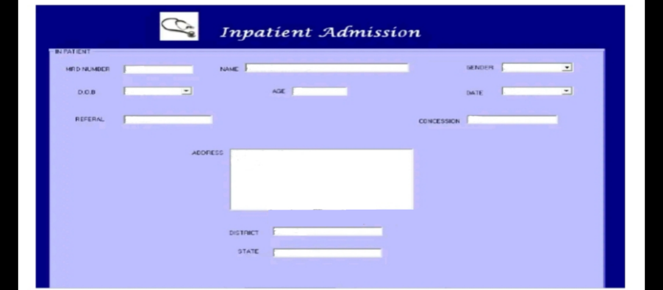

Imports System.Data.OleDb Public Class inpatient
Private Sub Button2_Click(ByVal sender As System.Object, ByVal e As System.EventArgs) Handles Button2.Click
Dim cmd As New OleDbCommand
conn.open()
Dim sql As String = "insert into ipt values ("& TextBox6.Text & " ," & TextBox5. Text & ", " & TextBox4.Text & RichTextBox4.Text & ", " & DateTimePickerl.Text & ","& ComboBox1.Text & ", " & TextBox2.Text & " TextBox3.Text & ", & TextBox7. Text & ", " && DateTimePicker2.Text & ")" & TextBox8.Text
cmd = New OleDbCommand (sql, conn)
cmd.ExecuteReader()
MsgBox("Record Inserted", MsgBoxStyle.Information, Hospital Management")
TextBox2.Text =
TextBox3.Text =
TextBox4.Text
RichTextBox4.Text
TextBox5.Text =
TextBox6.Text -
TextBox7. Text
TextBox8.Text =
ComboBox1.Text =
End Sub
conn.close()
Private Sub inpatient Load (ByVal sender As System.Object, ByVal e As System.EventArgs) Handles MyBase.Load Me.ComboBox1.Items.Add("Male")
End Sub
Me.ComboBox1.Items.Add("Female")
Private Sub Button1_Click(ByVal sender As System.Object, ByVal e As System.EventArgs) Handles Button1.Click Me.Hide()
mainmenu.Show()
End Sub
Private Sub Button4_Click(ByVal sender As System.Object, ByVal e As System.EventArgs) Handles Button4.Click iptrecord.Show()
End Sub
End Class
OUTPATIENT ADMISSION:
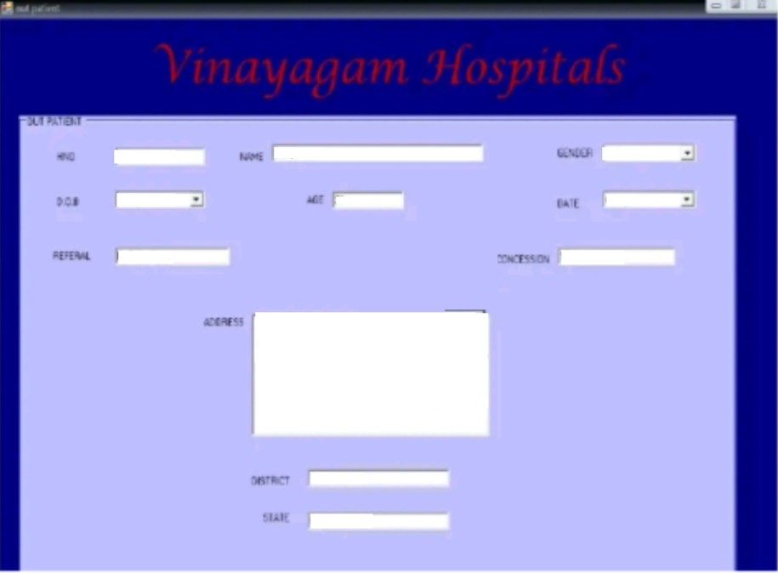
Imports System.Data.OleDb
Public Class outpatien
Private Sub Button1_Click(ByVal sender As System.Object, ByVal e As System.EventArgs) Handles Button1.cllak Me. Hide ()
mainmenu.Show(
End Sub
Private Sub Button2_Click(ByVal sender As System.Object, ByVal e As System.EventArgs) Handles Button2.Click
Dim ond As New OleDbCommand
conn.open()
Dim sql As String insert into opt values(!" & - Text Box6.Text & ", " & TextBox5.Text & ", " & TextRox4. Text & RichTextBox1.Text & "", & DateTimePickerl.Text & ,& ComboBox1.Text & "," & TextBox2.Text & TextBox3.Text & "", & TextBox.Text & ", & TextBox8. Text
cmd = New OleDbCommand(sql, conn)
cmd.ExecuteReader() MsgBox("Record Inserted", MsgBoxStyle.Information, "Hospital Management")
TextBox2.Text =
TextBox3.Text = TextBox4.Text =
RichTextBox4.Text TextBox5.Text =
TextBox6.Text =
TextBox7.Text =
TextBox8.Text =
ComboBox1.Text =
conn.close()
End Sub
Private Sub outpatient Load (ByVal sender As System.Object, ByVal e As System.EventArgs) Handles MyBase.Load Me.ComboBox1.Ttems.Add("Male")
Me.ComboBox1.Items.Add("Female")
End Sub End Class
Inpatient Bill:
Imports System.Data
Imports System.Data.OleDb
Public Class inpathill
Dim adp As New OleDbDataAdapter
Dim ds As New DataSet
Dim x As New Integer
Din and As New OleDbCommand
Dim dr As OleDbDataReader
Private Sub Button1_Click(ByVal sender As System.Object, ByVal e As System.EventArgs) Handles Button.click
Me.Hide()
mainmenu.Show()
End Sub
Private Sub Button2_Click(ByVal sender As System.Object, ByVal e As System.EventArgs) Handles Button2.Click
conn.open()
cmd New OleDbCommand("insert into inbill values ("" & TextBox1.Text & "* "& ComboBox1.Text & "," & TextBox3.Text && DateTimePicker2.Text & ", " & TextBox.Text & ",* & TextBox9.Text & "','" & DateTimePickerl.Text & ", " & DateTimePicker2. Text & "','" & TextBox11.Text & ")", conn)
cmd.ExecuteNonQuery()
MsgBox("Bill Saved to Database", MsgBoxStyle.OkOnly,
"Hospital Management")
cmd.Dispose() TextBox1.Text
TextBox3.Text
TextBox8.Text =
TextBox9. Text
TextBox10.Text
TextBox11.Text =
ComboBox1.Text = "
DateTimePickerl.Value = Now.Date DateTimePicker2.value = Now.Date
conn.close()
End Sub
Private Sub inpathill Load (ByVal sender As System.Object, ByVal e As System.EventArgs) Handles MyBase.Load
ComboBox1.TabIndex - 0
TextBox9. Tabindex=1
TextBox10.TabIndex = 2
TextBox11.TabIndex-3
conn.open()
cmd = New OleDbCommand("select from ipt", conn)
drand.ExecuteReader
While (dr.Read
ComboBox1.Items.Add(dr (0).ToString)
End while
cmd.Dispose()
cind - New OleDbCommand("select max (bno) from Inbill",
conn)
dr cmd.ExecuteReader
If dr.ReadTrue Then
TextBox1.Text. dr (0) + 1.ToString
Else
TextBox1.Text 1
End If
cmd.Dispose()
conn.close()
End Sub
Private Sub ComboBox1_SelectedIndexChanged (ByVal sender As System.Object, ByVal e As System.EventArgs) Handles ComboBox1.SelectedIndexChanged
conn.open()
adp - New OleDbDataAdapter ("select from ipt where mrdne-"ComboBox1.Text & adp.Fill(ds, "ipt") "", adpx)
TextBox3.Text = ds.Tables (0) .Rows (0) (1).ToString DateTimePickerl.Value - ds.Tables (0) -Rows (0)
( 10).ToString())
DateTimePicker2.Value = Now.Date: x DateTimePicker2.Value.Day -
DateTimePickerl.Value.Day
TextBox8.Text = x * 300 conn.close()
End Sub
Private Sub TextBox11_Enter (ByVal sender As Object, ByVal e As System.EventArgs) Handles TextBox11.Enter
TextBox11.Text =
Dim x, y, z As New Integer
x= TextBox8. Text
y= TextBox9. Text
z= TextBox10, Text
TextBox11.Text = x + y + z
End Sub
Private Sub Button4 _Click(ByVal sender As System.Object, ByVal e As System.EventArgs) Handles Button4.Click iptbillview.Show()
End Sub
End Class

OUTPATIENT RECORD SEARCH:
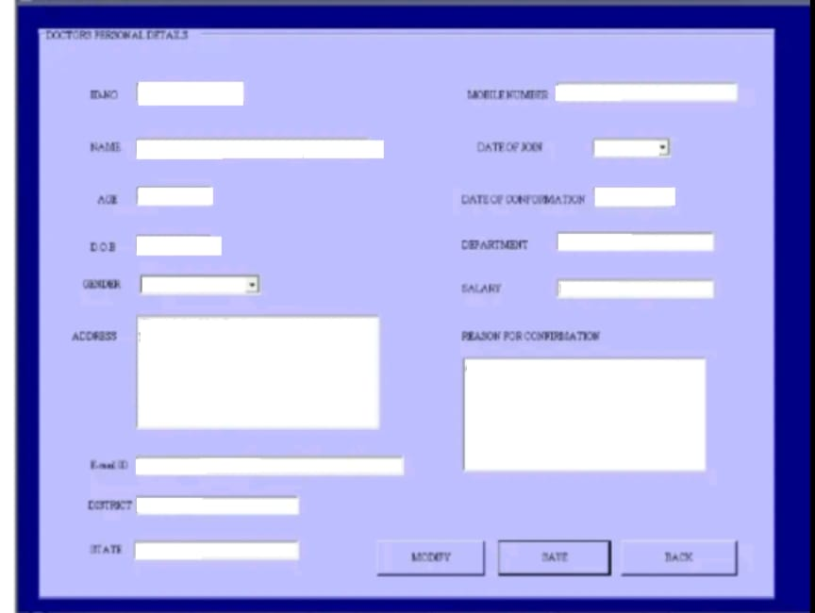
Imports System.Data.OleDb Imports System.Data
Public Class outpatbill
Dim adp As New OleDbDataAdapter
Fin da As New DataSet. Dim x As New Integer
Dim cmd As New OleDbCommand Dim dr As OleDbDataReader
Private Sub Button1_Click(ByVal sender As System.Object, ByVal e As System.EventArgs) Handles Burton1.click
Me.Hide()
mainmenu.Show()
End Sub
Private Sub Button2_Click(ByVal sender As System.Object, ByVal e As System.EventArgs) Handles Button2.click
conn.open()
and - New OleDbCommand("Insert into bill values(" TextBox1.Text & ", " & ComboBox1.Text & ", " & TextBox2.Text & ", " & TextBox3.Text & ", " & DateTimePickerl. Text & ", "
& TextBox7. Text & ")", conn) cmd.ExecuteNonQuery()
MsgBox("Record inserted to Database", MsgBoxstyle.Okoniy, "Hospital Management")
cleardata() conn.close()
End Sub
Sub clearcata ()
TextBox1.Text Nothing
TextBox2.Text - Nothing TextBox3.Text = Nothing
TextBox.Text - Nothing
ComboBox1.Text - Nothing
End Sub
Private Sub ComboBox1_SelectedIndexChanged(ByVal sender As System.Object, ByVal e As System.EventArgs) Handles ComboBox1.SelectedIndexChanged:
conn.open()
adp - New OleDbDataAdapter("select from opt where & ComboBox1.Text & "", adpx) adp.Fill(ds, "opt")
TextBox2.Text = ds.Tables (0).Rows (0) (1).ToString TextBox3.Text = ds.Tables (0).Rows (0) (9).ToString
conn.close()
End Sub
Private Sub outpatbill_Load(ByVal sender As System.Object, ByVal e As System.EventArgs) Handles MyBase.Load
conn.open()
cmd = New OleDbCommand("select from opt", conn)
dr cmd.ExecuteReader
While (dr.Read)
ComboBox1.Items.Add(dr (0).ToString)
End While
cmd.Dispose()
and New OleDbCommand("select max (bno) from hill",
dr cmd.ExecuteReader
If dr.Read - True Then
TextBox1.Text = dr (0) + 1.ToString
TextBox1.Text = 1
End T
End Sub
cmd. Dispose()
Private Sub Button1_Click(ByVal sender As System.Object, ByVal e As System.EventArgs) Handles Button4.click
cleardata ()
End Sub
Private Sub Button5_Click(ByVal sender As System.Object, ByVal e As System.EventArgs) Handles Button5.click
End Sub
outbillview.Show()
End Class
INPATIENT RECORD SEARCH:
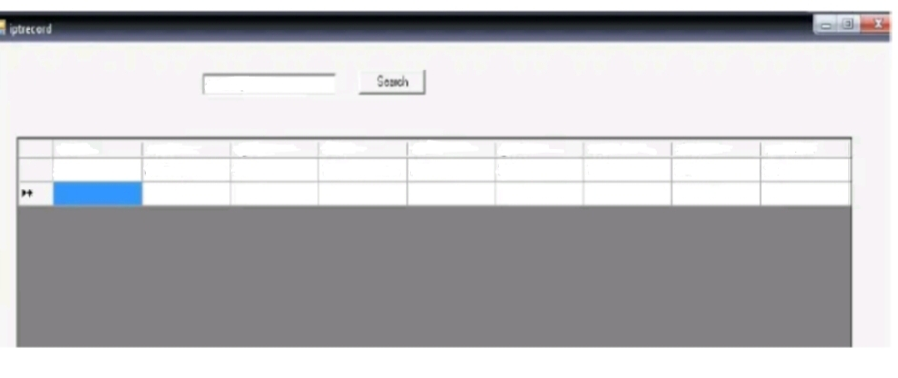

Imports System.Data
Imports System.Data.OleDb
Public Class iptrecord
Private Sub Button1_Click(ByVal sender As System.Object, ByVal e As System.EventArgs) Handles Button1.Click
conn.open()
Try Dim sql As String "select * from Igit where name & TextBox1.Text & "ER
Dim adp As OleDbDataAdapter
adp - New OleDbDataAdapter (sql, adpx)
Dim da As DataSet- New DataSet. adp.Fill(ds, "ipt")
DataGridView1.DataSource= ds.Tables ("ipt") Catch
MsgBox("Record not. Found", "Hospital
Management")
End Try
conn.close()
End Sub
Private Sub iptrecord_Load (ByVal sender As System.Object, ByVal e As System.EventArgs) Handles MyBase.Load TextBox1.Focus()
End Sub
End Class
Consultation:
Imports System.Data
Imports System.Data.OleDb
Public Class consul Dim cmd As New OleDbCommand
Dim adp As New OleDbDataAdapter
Dim ds As New DataSet
Din dr As OleDbDataReader
Private Sub Button5_Click(ByVal sender As System.Object, ByVal e As System.EventArgs) Handles Buttons.Click
Me.Hide()
mainmenu.Show()
End Sub
Private Sub consul Load (ByVal sender As System.Object, ByVal e As System.EventArgs) Handles MyBase.Load
DataGridView1.Hide ()
cmd = New OleDbCommand("select from ipt", conn)
conn.open()
dr cmd.ExecuteReader
while (dr.Read)
ComboBox1.Items.Add(dr (0).ToString)
End While cmd.Dispose()
End Sub
Private Sub ComboBox1 SelectedIndexChanged (ByVal sender As System.Object, ByVal e As System.EventArgs) Handles ComboBox1.SelectedIndexChanged adp New OleDbDataAdapter("select * from 1pt where
mrdnc-
"& ComboBox1.Text & "", adpx)
adp.Fill(ds, "ipt").
TextBox2.Text = ds.Tables (0).Rows (0) (1).ToString
TextBox3.Text ds.Tables (0) .Rows (0) (2).ToString - ComboBox2.Text - da.Tables (0).Rows (0) (5).ToString
DateTimePickerl.ValueNow.Date
End Sub
MsgBox("Record inserted to Database", MsgBoxStyle.OkOnly, "Hospital Management")
cleardata()
cmd.Dispose()
End Sub
Sub clearcata ()
ComboBox1.Text = TextBox2.Text =
TextBox3.Text =
TextBox5.Text =
TextBox6.Text =
End Sub
Private Sub Button2_Click(ByVal sender As System.Object, ByVal e As System.EventArgs) Handles Button2.Click
cleardata()
Private Sub Button1_Click(ByVal sender As System.Object, ByVal e As System.EventArgs) Handles Button4.click
DataGridView1.Show()
Try
Dim sql As String = "select from cons where
& ComboBox1.Text & ""
mrdno=
Dim adp As OleDbDataAdapter
adp New OleDbDataAdapter (sql, adpx)
Dim da As DataSet New DataSet
adp.Fill(ds, "cons")
DataGridView1.DataSource = ds.Tables ("cons")
Catch
Management")
MagBox("Record not Found", "Hospital
End Try
conn.close()
End Sub
End Class
Module:
Tmports System.Data.OleD
Module Modulel
Public v As New OleDbConnection
Public adpx As String "Provider=SQLOLEDB; Data
Catalog-hospital1"
Source-ARULSOFT; Tntegrated Security-SSPT; Initial
Public x As Integer - New Integer +1 Public Sub opendata ()
v.ConnectionString - "Provider-SQLOLEDB; Data.
Source-ARULSOFT; Integrated Security-SSPI; Initial Catalog-hospitall"
End Sub
v.Open()
Public Sub closedata()
v.Close()
y Nothing End Sub
End Modul

OUTPUT:
HOME SCREEN:
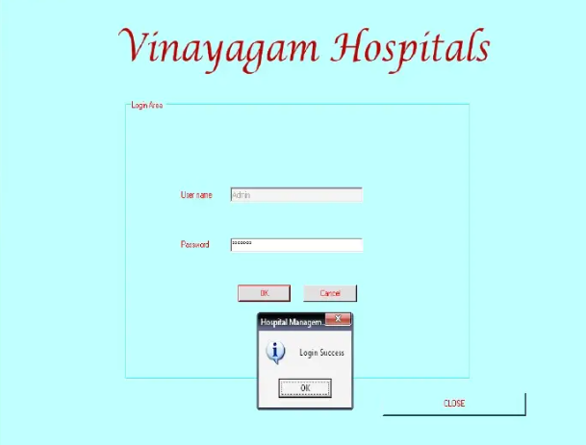


INPATIENT ADMISSSION
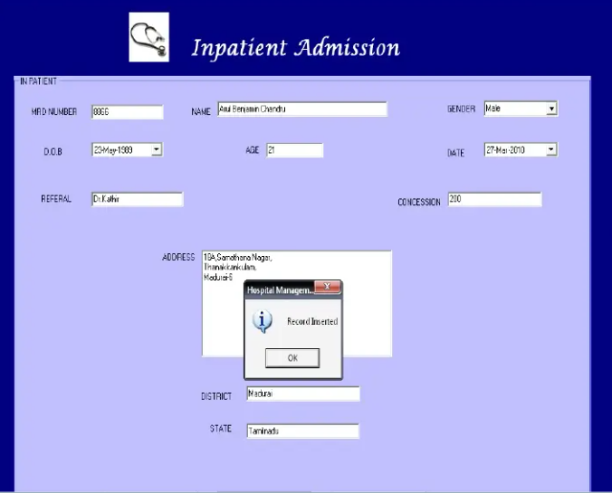
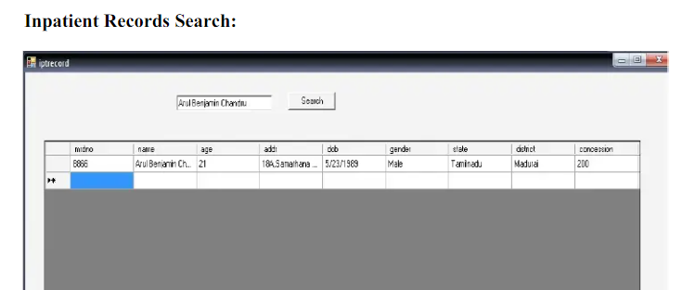
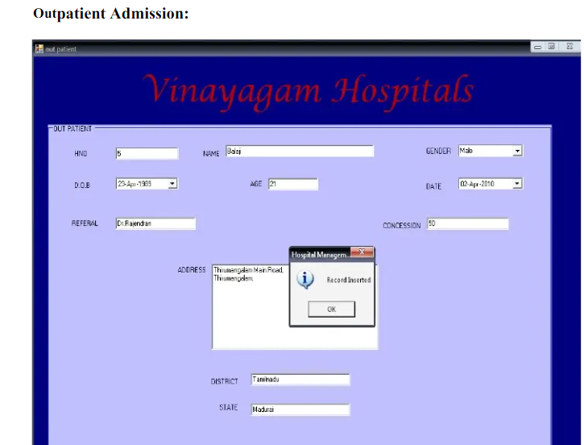
OUTPATIENT RECORD SEARCH:
